**US Accidents Query Solutions**

***By Somendra, Pablo and Balaji***

## Query 1

WITH sev1 as(SELECT DISTINCT count(id) as Acc_Sev1, state

FROM us_accident_v3

WHERE severity = 1

GROUP BY state),

sev2 as(SELECT DISTINCT count(id) as Acc_Sev2, state

FROM us_accident_v3

WHERE severity = 2

GROUP BY state),

sev3 as(SELECT DISTINCT count(id) as Acc_Sev3, state

FROM us_accident_v3

WHERE severity = 3

GROUP BY state),

sev4 as(SELECT DISTINCT count(id) as Acc_Sev4, state

FROM us_accident_v3

WHERE severity = 4

GROUP BY state)

SELECT sev1.state, Acc_Sev1, Acc_Sev2, Acc_Sev3, Acc_Sev4

FROM sev1, sev2, sev3, sev4

WHERE sev1.state = sev2.state AND

sev2.state = sev3.state AND

sev3.state = sev4.state

ORDER BY sev1.state ASC;

## Query 3

SELECT DISTINCT

(SELECT avg(date_diff('hour',start_time,end_time))

FROM us_accident_v3

WHERE severity = 4) AS Avg_dur_sev_4,

(SELECT stddev(date_diff('hour',start_time,end_time))

FROM us_accident_v3

WHERE severity = 4) AS Stddev_dur_sev_4,

(SELECT max(date_diff('hour',start_time,end_time))

FROM us_accident_v3

WHERE severity = 4) AS Max_dur_sev_4,

(SELECT avg(date_diff('hour',start_time,end_time))

FROM us_accident_v3

WHERE severity = 3) AS Avg_dur_sev_3,

(SELECT stddev(date_diff('hour',start_time,end_time))

FROM us_accident_v3

WHERE severity = 3) AS Stddev_dur_sev_3,

(SELECT max(date_diff('hour',start_time,end_time))

FROM us_accident_v3

WHERE severity = 3) AS Max_dur_sev_3,

(SELECT avg(date_diff('hour',start_time,end_time))

FROM us_accident_v3

WHERE severity = 2) AS Avg_dur_sev_2,

(SELECT stddev(date_diff('hour',start_time,end_time))

FROM us_accident_v3

WHERE severity = 2) AS Stddev_dur_sev_2,

(SELECT max(date_diff('hour',start_time,end_time))

FROM us_accident_v3

WHERE severity = 2) AS Max_dur_sev_2,

(SELECT avg(date_diff('hour',start_time,end_time))

FROM us_accident_v3

WHERE severity = 1) AS Avg_dur_sev_1,

(SELECT stddev(date_diff('hour',start_time,end_time))

FROM us_accident_v3

WHERE severity = 1) AS Stddev_dur_sev_1,

(SELECT max(date_diff('hour',start_time,end_time))

FROM us_accident_v3

WHERE severity = 1) AS Max_dur_sev_1

FROM us_accident_v3

|  |  |  |  |  |  |  |  |  |  |  |  |
| --- | --- | --- | --- | --- | --- | --- | --- | --- | --- | --- | --- |
| **Avg_dur_sev_4** | **Stddev_dur_sev_4** | **Max_dur_sev_4** | **Avg_dur_sev_3** | **Stddev_dur_sev_3** | **Max_dur_sev_3** | **Avg_dur_sev_2** | **Stddev_dur_sev_2** | **Max_dur_sev_2** | **Avg_dur_sev_1** | **Stddev_dur_sev_1** | **Max_dur_sev_1** |
| 14.968.517.495.695.100 | 32.087.079.269.167.700 | 29772 | 0.7972950136319596 | 333.474.785.302.814 | 13043 | 1.229.546.856.893.460 | 183.392.882.414.965 | 8337 | 0.2572314049586777 | 0.5214622073330124 | 5 |



## Query 4

with s4g as (select distinct date, severity, count(*) over (partition by severity) as Sev4_Good_cnt

from

(select date(start_time) as date, severity

from us_accident_v3

where year(start_time) > 2018 and

severity = 4 and

(weather_condition = 'Clear' OR

weather_condition = 'Cloudy' OR

weather_condition = 'Cloudy / Windy' OR

weather_condition = 'Drizzle' OR

weather_condition = 'Drizzle / Windy' OR

weather_condition = 'Fair' OR

weather_condition = 'Fair / Windy' OR

weather_condition = 'Haze' OR

weather_condition = 'Light Blowing Snow' OR

weather_condition = 'Light Drizzle' OR

weather_condition = 'Light Drizzle / Windy' OR

weather_condition = 'Light Fog' OR

weather_condition = 'Light Freezing Drizzle' OR

weather_condition = 'Light Freezing Fog' OR

weather_condition = 'Light Freezing Rain' OR

weather_condition = 'Light Freezing Rain / Windy' OR

weather_condition = 'Light Hail' OR

weather_condition = 'Light Haze' OR

weather_condition = 'Light Ice Pellets' OR

weather_condition = 'Light Rain' OR

weather_condition = 'Light Rain / Windy' OR

weather_condition = 'Light Rain Shower' OR

weather_condition = 'Light Rain Shower / Windy' OR

weather_condition = 'Light Rain Showers' OR

weather_condition = 'Light Sleet' OR

weather_condition = 'Light Snow' OR

weather_condition = 'Light Snow and Sleet' OR

weather_condition = 'Light Snow Grains' OR

weather_condition = 'Light Snow Shower' OR

weather_condition = 'Light Snow Showers' OR

weather_condition = 'Light Thunderstorms and Rain' OR

weather_condition = 'Light Thunderstorms and Snow' OR

weather_condition = 'Mist' OR

weather_condition = 'Mostly Cloudy' OR

weather_condition = 'Mostly Cloudy / Windy' OR

weather_condition = 'N/A Precipitation' OR

weather_condition = 'Overcast' OR

weather_condition = 'Partial Fog' OR

weather_condition = 'Partial Fog / Windy' OR

weather_condition = 'Partly Cloudy' OR

weather_condition = 'Partly Cloudy / Windy' OR

weather_condition = 'Patches of Fog' OR

weather_condition = 'Scattered Clouds' OR

weather_condition = 'Shallow Fog' OR

weather_condition = 'Showers in the Vicinity' OR

weather_condition = 'Small Hail' OR

weather_condition = 'Thunder in the Vicinity')

order by month(start_time), date(start_time))

order by severity desc, Sev4_Good_cnt desc),

s4b as (select distinct date, severity, count(*) over (partition by severity) as Sev4_Bad_cnt

from

(select date(start_time) as date, severity

from us_accident_v3

where year(start_time) > 2018 and

severity = 4 and

weather_condition NOT LIKE 'Clear' AND

weather_condition NOT LIKE 'Cloudy' AND

weather_condition NOT LIKE 'Cloudy / Windy' AND

weather_condition NOT LIKE 'Drizzle' AND

weather_condition NOT LIKE 'Drizzle / Windy' AND

weather_condition NOT LIKE 'Fair' AND

weather_condition NOT LIKE 'Fair / Windy' AND

weather_condition NOT LIKE 'Haze' AND

weather_condition NOT LIKE 'Light Blowing Snow' AND

weather_condition NOT LIKE 'Light Drizzle' AND

weather_condition NOT LIKE 'Light Drizzle / Windy' AND

weather_condition NOT LIKE 'Light Fog' AND

weather_condition NOT LIKE 'Light Freezing Drizzle' AND

weather_condition NOT LIKE 'Light Freezing Fog' AND

weather_condition NOT LIKE 'Light Freezing Rain' AND

weather_condition NOT LIKE 'Light Freezing Rain / Windy' AND

weather_condition NOT LIKE 'Light Hail' AND

weather_condition NOT LIKE 'Light Haze' AND

weather_condition NOT LIKE 'Light Ice Pellets' AND

weather_condition NOT LIKE 'Light Rain' AND

weather_condition NOT LIKE 'Light Rain / Windy' AND

weather_condition NOT LIKE 'Light Rain Shower' AND

weather_condition NOT LIKE 'Light Rain Shower / Windy' AND

weather_condition NOT LIKE 'Light Rain Showers' AND

weather_condition NOT LIKE 'Light Sleet' AND

weather_condition NOT LIKE 'Light Snow' AND

weather_condition NOT LIKE 'Light Snow and Sleet' AND

weather_condition NOT LIKE 'Light Snow Grains' AND

weather_condition NOT LIKE 'Light Snow Shower' AND

weather_condition NOT LIKE 'Light Snow Showers' AND

weather_condition NOT LIKE 'Light ThunderstANDms and Rain' AND

weather_condition NOT LIKE 'Light ThunderstANDms and Snow' AND

weather_condition NOT LIKE 'Mist' AND

weather_condition NOT LIKE 'Mostly Cloudy' AND

weather_condition NOT LIKE 'Mostly Cloudy / Windy' AND

weather_condition NOT LIKE 'N/A Precipitation' AND

weather_condition NOT LIKE 'Overcast' AND

weather_condition NOT LIKE 'Partial Fog' AND

weather_condition NOT LIKE 'Partial Fog / Windy' AND

weather_condition NOT LIKE 'Partly Cloudy' AND

weather_condition NOT LIKE 'Partly Cloudy / Windy' AND

weather_condition NOT LIKE 'Patches of Fog' AND

weather_condition NOT LIKE 'Scattered Clouds' AND

weather_condition NOT LIKE 'Shallow Fog' AND

weather_condition NOT LIKE 'Showers in the Vicinity' AND

weather_condition NOT LIKE 'Small Hail' AND

weather_condition NOT LIKE 'Thunder in the Vicinity'

order by month(start_time), date(start_time))

order by severity desc, Sev4_Bad_cnt desc),

s3g as (select distinct date, severity, count(*) over (partition by severity) as Sev3_Good_cnt

from

(select date(start_time) as date, severity

from us_accident_v3

where year(start_time) > 2018 and

severity = 3 and

(weather_condition = 'Clear' OR

weather_condition = 'Cloudy' OR

weather_condition = 'Cloudy / Windy' OR

weather_condition = 'Drizzle' OR

weather_condition = 'Drizzle / Windy' OR

weather_condition = 'Fair' OR

weather_condition = 'Fair / Windy' OR

weather_condition = 'Haze' OR

weather_condition = 'Light Blowing Snow' OR

weather_condition = 'Light Drizzle' OR

weather_condition = 'Light Drizzle / Windy' OR

weather_condition = 'Light Fog' OR

weather_condition = 'Light Freezing Drizzle' OR

weather_condition = 'Light Freezing Fog' OR

weather_condition = 'Light Freezing Rain' OR

weather_condition = 'Light Freezing Rain / Windy' OR

weather_condition = 'Light Hail' OR

weather_condition = 'Light Haze' OR

weather_condition = 'Light Ice Pellets' OR

weather_condition = 'Light Rain' OR

weather_condition = 'Light Rain / Windy' OR

weather_condition = 'Light Rain Shower' OR

weather_condition = 'Light Rain Shower / Windy' OR

weather_condition = 'Light Rain Showers' OR

weather_condition = 'Light Sleet' OR

weather_condition = 'Light Snow' OR

weather_condition = 'Light Snow and Sleet' OR

weather_condition = 'Light Snow Grains' OR

weather_condition = 'Light Snow Shower' OR

weather_condition = 'Light Snow Showers' OR

weather_condition = 'Light Thunderstorms and Rain' OR

weather_condition = 'Light Thunderstorms and Snow' OR

weather_condition = 'Mist' OR

weather_condition = 'Mostly Cloudy' OR

weather_condition = 'Mostly Cloudy / Windy' OR

weather_condition = 'N/A Precipitation' OR

weather_condition = 'Overcast' OR

weather_condition = 'Partial Fog' OR

weather_condition = 'Partial Fog / Windy' OR

weather_condition = 'Partly Cloudy' OR

weather_condition = 'Partly Cloudy / Windy' OR

weather_condition = 'Patches of Fog' OR

weather_condition = 'Scattered Clouds' OR

weather_condition = 'Shallow Fog' OR

weather_condition = 'Showers in the Vicinity' OR

weather_condition = 'Small Hail' OR

weather_condition = 'Thunder in the Vicinity')

order by month(start_time), date(start_time))

order by severity desc, Sev3_Good_cnt desc),

s3b as (select distinct date, severity, count(*) over (partition by severity) as Sev3_Bad_cnt

from

(select date(start_time) as date, severity

from us_accident_v3

where year(start_time) > 2018 and

severity = 3 and

weather_condition NOT LIKE 'Clear' AND

weather_condition NOT LIKE 'Cloudy' AND

weather_condition NOT LIKE 'Cloudy / Windy' AND

weather_condition NOT LIKE 'Drizzle' AND

weather_condition NOT LIKE 'Drizzle / Windy' AND

weather_condition NOT LIKE 'Fair' AND

weather_condition NOT LIKE 'Fair / Windy' AND

weather_condition NOT LIKE 'Haze' AND

weather_condition NOT LIKE 'Light Blowing Snow' AND

weather_condition NOT LIKE 'Light Drizzle' AND

weather_condition NOT LIKE 'Light Drizzle / Windy' AND

weather_condition NOT LIKE 'Light Fog' AND

weather_condition NOT LIKE 'Light Freezing Drizzle' AND

weather_condition NOT LIKE 'Light Freezing Fog' AND

weather_condition NOT LIKE 'Light Freezing Rain' AND

weather_condition NOT LIKE 'Light Freezing Rain / Windy' AND

weather_condition NOT LIKE 'Light Hail' AND

weather_condition NOT LIKE 'Light Haze' AND

weather_condition NOT LIKE 'Light Ice Pellets' AND

weather_condition NOT LIKE 'Light Rain' AND

weather_condition NOT LIKE 'Light Rain / Windy' AND

weather_condition NOT LIKE 'Light Rain Shower' AND

weather_condition NOT LIKE 'Light Rain Shower / Windy' AND

weather_condition NOT LIKE 'Light Rain Showers' AND

weather_condition NOT LIKE 'Light Sleet' AND

weather_condition NOT LIKE 'Light Snow' AND

weather_condition NOT LIKE 'Light Snow and Sleet' AND

weather_condition NOT LIKE 'Light Snow Grains' AND

weather_condition NOT LIKE 'Light Snow Shower' AND

weather_condition NOT LIKE 'Light Snow Showers' AND

weather_condition NOT LIKE 'Light ThunderstANDms and Rain' AND

weather_condition NOT LIKE 'Light ThunderstANDms and Snow' AND

weather_condition NOT LIKE 'Mist' AND

weather_condition NOT LIKE 'Mostly Cloudy' AND

weather_condition NOT LIKE 'Mostly Cloudy / Windy' AND

weather_condition NOT LIKE 'N/A Precipitation' AND

weather_condition NOT LIKE 'Overcast' AND

weather_condition NOT LIKE 'Partial Fog' AND

weather_condition NOT LIKE 'Partial Fog / Windy' AND

weather_condition NOT LIKE 'Partly Cloudy' AND

weather_condition NOT LIKE 'Partly Cloudy / Windy' AND

weather_condition NOT LIKE 'Patches of Fog' AND

weather_condition NOT LIKE 'Scattered Clouds' AND

weather_condition NOT LIKE 'Shallow Fog' AND

weather_condition NOT LIKE 'Showers in the Vicinity' AND

weather_condition NOT LIKE 'Small Hail' AND

weather_condition NOT LIKE 'Thunder in the Vicinity'

order by month(start_time), date(start_time))

order by severity desc, Sev3_Bad_cnt desc),

s2g as (select distinct date, severity, count(*) over (partition by severity) as Sev2_Good_cnt

from

(select date(start_time) as date, severity

from us_accident_v3

where year(start_time) > 2018 and

severity = 2 and

(weather_condition = 'Clear' OR

weather_condition = 'Cloudy' OR

weather_condition = 'Cloudy / Windy' OR

weather_condition = 'Drizzle' OR

weather_condition = 'Drizzle / Windy' OR

weather_condition = 'Fair' OR

weather_condition = 'Fair / Windy' OR

weather_condition = 'Haze' OR

weather_condition = 'Light Blowing Snow' OR

weather_condition = 'Light Drizzle' OR

weather_condition = 'Light Drizzle / Windy' OR

weather_condition = 'Light Fog' OR

weather_condition = 'Light Freezing Drizzle' OR

weather_condition = 'Light Freezing Fog' OR

weather_condition = 'Light Freezing Rain' OR

weather_condition = 'Light Freezing Rain / Windy' OR

weather_condition = 'Light Hail' OR

weather_condition = 'Light Haze' OR

weather_condition = 'Light Ice Pellets' OR

weather_condition = 'Light Rain' OR

weather_condition = 'Light Rain / Windy' OR

weather_condition = 'Light Rain Shower' OR

weather_condition = 'Light Rain Shower / Windy' OR

weather_condition = 'Light Rain Showers' OR

weather_condition = 'Light Sleet' OR

weather_condition = 'Light Snow' OR

weather_condition = 'Light Snow and Sleet' OR

weather_condition = 'Light Snow Grains' OR

weather_condition = 'Light Snow Shower' OR

weather_condition = 'Light Snow Showers' OR

weather_condition = 'Light Thunderstorms and Rain' OR

weather_condition = 'Light Thunderstorms and Snow' OR

weather_condition = 'Mist' OR

weather_condition = 'Mostly Cloudy' OR

weather_condition = 'Mostly Cloudy / Windy' OR

weather_condition = 'N/A Precipitation' OR

weather_condition = 'Overcast' OR

weather_condition = 'Partial Fog' OR

weather_condition = 'Partial Fog / Windy' OR

weather_condition = 'Partly Cloudy' OR

weather_condition = 'Partly Cloudy / Windy' OR

weather_condition = 'Patches of Fog' OR

weather_condition = 'Scattered Clouds' OR

weather_condition = 'Shallow Fog' OR

weather_condition = 'Showers in the Vicinity' OR

weather_condition = 'Small Hail' OR

weather_condition = 'Thunder in the Vicinity')

order by month(start_time), date(start_time))

order by severity desc, Sev2_Good_cnt desc),

s2b as (select distinct date, severity, count(*) over (partition by severity) as Sev2_Bad_cnt

from

(select date(start_time) as date, severity

from us_accident_v3

where year(start_time) > 2018 and

severity = 2 and

weather_condition NOT LIKE 'Clear' AND

weather_condition NOT LIKE 'Cloudy' AND

weather_condition NOT LIKE 'Cloudy / Windy' AND

weather_condition NOT LIKE 'Drizzle' AND

weather_condition NOT LIKE 'Drizzle / Windy' AND

weather_condition NOT LIKE 'Fair' AND

weather_condition NOT LIKE 'Fair / Windy' AND

weather_condition NOT LIKE 'Haze' AND

weather_condition NOT LIKE 'Light Blowing Snow' AND

weather_condition NOT LIKE 'Light Drizzle' AND

weather_condition NOT LIKE 'Light Drizzle / Windy' AND

weather_condition NOT LIKE 'Light Fog' AND

weather_condition NOT LIKE 'Light Freezing Drizzle' AND

weather_condition NOT LIKE 'Light Freezing Fog' AND

weather_condition NOT LIKE 'Light Freezing Rain' AND

weather_condition NOT LIKE 'Light Freezing Rain / Windy' AND

weather_condition NOT LIKE 'Light Hail' AND

weather_condition NOT LIKE 'Light Haze' AND

weather_condition NOT LIKE 'Light Ice Pellets' AND

weather_condition NOT LIKE 'Light Rain' AND

weather_condition NOT LIKE 'Light Rain / Windy' AND

weather_condition NOT LIKE 'Light Rain Shower' AND

weather_condition NOT LIKE 'Light Rain Shower / Windy' AND

weather_condition NOT LIKE 'Light Rain Showers' AND

weather_condition NOT LIKE 'Light Sleet' AND

weather_condition NOT LIKE 'Light Snow' AND

weather_condition NOT LIKE 'Light Snow and Sleet' AND

weather_condition NOT LIKE 'Light Snow Grains' AND

weather_condition NOT LIKE 'Light Snow Shower' AND

weather_condition NOT LIKE 'Light Snow Showers' AND

weather_condition NOT LIKE 'Light ThunderstANDms and Rain' AND

weather_condition NOT LIKE 'Light ThunderstANDms and Snow' AND

weather_condition NOT LIKE 'Mist' AND

weather_condition NOT LIKE 'Mostly Cloudy' AND

weather_condition NOT LIKE 'Mostly Cloudy / Windy' AND

weather_condition NOT LIKE 'N/A Precipitation' AND

weather_condition NOT LIKE 'Overcast' AND

weather_condition NOT LIKE 'Partial Fog' AND

weather_condition NOT LIKE 'Partial Fog / Windy' AND

weather_condition NOT LIKE 'Partly Cloudy' AND

weather_condition NOT LIKE 'Partly Cloudy / Windy' AND

weather_condition NOT LIKE 'Patches of Fog' AND

weather_condition NOT LIKE 'Scattered Clouds' AND

weather_condition NOT LIKE 'Shallow Fog' AND

weather_condition NOT LIKE 'Showers in the Vicinity' AND

weather_condition NOT LIKE 'Small Hail' AND

weather_condition NOT LIKE 'Thunder in the Vicinity'

order by month(start_time), date(start_time))

order by severity desc, Sev2_Bad_cnt desc),

s1g as (select distinct date, severity, count(*) over (partition by severity) as Sev1_Good_cnt

from

(select date(start_time) as date, severity

from us_accident_v3

where year(start_time) > 2018 and

severity = 1 and

(weather_condition = 'Clear' OR

weather_condition = 'Cloudy' OR

weather_condition = 'Cloudy / Windy' OR

weather_condition = 'Drizzle' OR

weather_condition = 'Drizzle / Windy' OR

weather_condition = 'Fair' OR

weather_condition = 'Fair / Windy' OR

weather_condition = 'Haze' OR

weather_condition = 'Light Blowing Snow' OR

weather_condition = 'Light Drizzle' OR

weather_condition = 'Light Drizzle / Windy' OR

weather_condition = 'Light Fog' OR

weather_condition = 'Light Freezing Drizzle' OR

weather_condition = 'Light Freezing Fog' OR

weather_condition = 'Light Freezing Rain' OR

weather_condition = 'Light Freezing Rain / Windy' OR

weather_condition = 'Light Hail' OR

weather_condition = 'Light Haze' OR

weather_condition = 'Light Ice Pellets' OR

weather_condition = 'Light Rain' OR

weather_condition = 'Light Rain / Windy' OR

weather_condition = 'Light Rain Shower' OR

weather_condition = 'Light Rain Shower / Windy' OR

weather_condition = 'Light Rain Showers' OR

weather_condition = 'Light Sleet' OR

weather_condition = 'Light Snow' OR

weather_condition = 'Light Snow and Sleet' OR

weather_condition = 'Light Snow Grains' OR

weather_condition = 'Light Snow Shower' OR

weather_condition = 'Light Snow Showers' OR

weather_condition = 'Light Thunderstorms and Rain' OR

weather_condition = 'Light Thunderstorms and Snow' OR

weather_condition = 'Mist' OR

weather_condition = 'Mostly Cloudy' OR

weather_condition = 'Mostly Cloudy / Windy' OR

weather_condition = 'N/A Precipitation' OR

weather_condition = 'Overcast' OR

weather_condition = 'Partial Fog' OR

weather_condition = 'Partial Fog / Windy' OR

weather_condition = 'Partly Cloudy' OR

weather_condition = 'Partly Cloudy / Windy' OR

weather_condition = 'Patches of Fog' OR

weather_condition = 'Scattered Clouds' OR

weather_condition = 'Shallow Fog' OR

weather_condition = 'Showers in the Vicinity' OR

weather_condition = 'Small Hail' OR

weather_condition = 'Thunder in the Vicinity')

order by month(start_time), date(start_time))

order by severity desc, Sev1_Good_cnt desc),

s1b as (select distinct date, severity, count(*) over (partition by severity) as Sev1_Bad_cnt

from

(select date(start_time) as date, severity

from us_accident_v3

where year(start_time) > 2018 and

severity = 1 and

weather_condition NOT LIKE 'Clear' AND

weather_condition NOT LIKE 'Cloudy' AND

weather_condition NOT LIKE 'Cloudy / Windy' AND

weather_condition NOT LIKE 'Drizzle' AND

weather_condition NOT LIKE 'Drizzle / Windy' AND

weather_condition NOT LIKE 'Fair' AND

weather_condition NOT LIKE 'Fair / Windy' AND

weather_condition NOT LIKE 'Haze' AND

weather_condition NOT LIKE 'Light Blowing Snow' AND

weather_condition NOT LIKE 'Light Drizzle' AND

weather_condition NOT LIKE 'Light Drizzle / Windy' AND

weather_condition NOT LIKE 'Light Fog' AND

weather_condition NOT LIKE 'Light Freezing Drizzle' AND

weather_condition NOT LIKE 'Light Freezing Fog' AND

weather_condition NOT LIKE 'Light Freezing Rain' AND

weather_condition NOT LIKE 'Light Freezing Rain / Windy' AND

weather_condition NOT LIKE 'Light Hail' AND

weather_condition NOT LIKE 'Light Haze' AND

weather_condition NOT LIKE 'Light Ice Pellets' AND

weather_condition NOT LIKE 'Light Rain' AND

weather_condition NOT LIKE 'Light Rain / Windy' AND

weather_condition NOT LIKE 'Light Rain Shower' AND

weather_condition NOT LIKE 'Light Rain Shower / Windy' AND

weather_condition NOT LIKE 'Light Rain Showers' AND

weather_condition NOT LIKE 'Light Sleet' AND

weather_condition NOT LIKE 'Light Snow' AND

weather_condition NOT LIKE 'Light Snow and Sleet' AND

weather_condition NOT LIKE 'Light Snow Grains' AND

weather_condition NOT LIKE 'Light Snow Shower' AND

weather_condition NOT LIKE 'Light Snow Showers' AND

weather_condition NOT LIKE 'Light ThunderstANDms and Rain' AND

weather_condition NOT LIKE 'Light ThunderstANDms and Snow' AND

weather_condition NOT LIKE 'Mist' AND

weather_condition NOT LIKE 'Mostly Cloudy' AND

weather_condition NOT LIKE 'Mostly Cloudy / Windy' AND

weather_condition NOT LIKE 'N/A Precipitation' AND

weather_condition NOT LIKE 'Overcast' AND

weather_condition NOT LIKE 'Partial Fog' AND

weather_condition NOT LIKE 'Partial Fog / Windy' AND

weather_condition NOT LIKE 'Partly Cloudy' AND

weather_condition NOT LIKE 'Partly Cloudy / Windy' AND

weather_condition NOT LIKE 'Patches of Fog' AND

weather_condition NOT LIKE 'Scattered Clouds' AND

weather_condition NOT LIKE 'Shallow Fog' AND

weather_condition NOT LIKE 'Showers in the Vicinity' AND

weather_condition NOT LIKE 'Small Hail' AND

weather_condition NOT LIKE 'Thunder in the Vicinity'

order by month(start_time), date(start_time))

order by severity desc, Sev1_Bad_cnt desc)

select s4g.date,

100 * s4g.Sev4_Good_cnt / (s4g.Sev4_Good_cnt + s4b.Sev4_Bad_cnt) as Sev4_Good,

100 * s4b.Sev4_Bad_cnt / (s4g.Sev4_Good_cnt + s4b.Sev4_Bad_cnt) as Sev4_Bad,

100 * s3g.Sev3_Good_cnt / (s3g.Sev3_Good_cnt + s3b.Sev3_Bad_cnt) as Sev3_Good,

100 * s3b.Sev3_Bad_cnt / (s3g.Sev3_Good_cnt + s3b.Sev3_Bad_cnt) as Sev3_Bad,

100 * s2g.Sev2_Good_cnt / (s2g.Sev2_Good_cnt + s2b.Sev2_Bad_cnt) as Sev2_Good,

100 * s2b.Sev2_Bad_cnt / (s2g.Sev2_Good_cnt + s2b.Sev2_Bad_cnt) as Sev2_Bad,

100 * s1g.Sev1_Good_cnt / (s1g.Sev1_Good_cnt + s1b.Sev1_Bad_cnt) as Sev1_Good,

100 * s1b.Sev1_Bad_cnt / (s1g.Sev1_Good_cnt + s1b.Sev1_Bad_cnt) as Sev1_Bad

from s4g, s4b, s3g, s3b, s2g, s2b, s1g, s1b

where s4g.date = s4b.date and

s3g.date = s3b.date and

s2g.date = s2b.date and

s1g.date = s1b.date and

s1g.date = s2g.date and

s2g.date = s3g.date and

s3g.date = s4g.date

## Query 5

**temperature**

select distinct date, temp_range_in_f, severity, weather_condn, count(*) over (partition by weather_condn, severity, temp_range_in_f) as cnt

from

(select date(start_time) as date,

case

when temperature between -80 and -71 then '-80 to -71'

when temperature between -70 and -61 then '-70 to -61'

when temperature between -60 and -51 then '-60 to -51'

when temperature between -50 and -41 then '-50 to -41'

when temperature between -40 and -31 then '-40 to -31'

when temperature between -30 and -21 then '-30 to -21'

when temperature between -20 and -11 then '-20 to -11'

when temperature between -10 and -1 then '-10 to -01'

when temperature between 0 and 9 then '0 to 9'

when temperature between 10 and 19 then '10 to 19'

when temperature between 20 and 29 then '20 to 29'

when temperature between 30 and 39 then '30 to 39'

when temperature between 40 and 49 then '40 to 49'

when temperature between 50 and 59 then '50 to 59'

when temperature between 60 and 69 then '60 to 69'

when temperature between 70 and 79 then '70 to 79'

when temperature between 80 and 89 then '80 to 89'

when temperature between 90 and 99 then '90 to 99'

when temperature between 100 and 109 then '100 to 109'

when temperature between 110 and 119 then '110 to 119'

when temperature between 120 and 129 then '120 to 129'

when temperature between 130 and 139 then '130 to 139'

when temperature between 140 and 149 then '140 to 149'

when temperature between 150 and 159 then '150 to 159'

when temperature between 160 and 169 then '160 to 169'

when temperature between 170 and 179 then '170 to 179'

else 'temperature unknown'

end as temp_range_in_f,

case

when weather_condition = 'Clear' then 'good'

when weather_condition = 'Cloudy' then 'good'

when weather_condition = 'Cloudy / Windy' then 'good'

when weather_condition = 'Drizzle' then 'good'

when weather_condition = 'Drizzle / Windy' then 'good'

when weather_condition = 'Fair' then 'good'

when weather_condition = 'Fair / Windy' then 'good'

when weather_condition = 'Haze' then 'good'

when weather_condition = 'Light Blowing Snow' then 'good'

when weather_condition = 'Light Drizzle' then 'good'

when weather_condition = 'Light Drizzle / Windy' then 'good'

when weather_condition = 'Light Fog' then 'good'

when weather_condition = 'Light Freezing Drizzle' then 'good'

when weather_condition = 'Light Freezing Fog' then 'good'

when weather_condition = 'Light Freezing Rain' then 'good'

when weather_condition = 'Light Freezing Rain / Windy' then 'good'

when weather_condition = 'Light Hail' then 'good'

when weather_condition = 'Light Haze' then 'good'

when weather_condition = 'Light Ice Pellets' then 'good'

when weather_condition = 'Light Rain' then 'good'

when weather_condition = 'Light Rain / Windy' then 'good'

when weather_condition = 'Light Rain Shower' then 'good'

when weather_condition = 'Light Rain Shower / Windy' then 'good'

when weather_condition = 'Light Rain Showers' then 'good'

when weather_condition = 'Light Sleet' then 'good'

when weather_condition = 'Light Snow' then 'good'

when weather_condition = 'Light Snow and Sleet' then 'good'

when weather_condition = 'Light Snow Grains' then 'good'

when weather_condition = 'Light Snow Shower' then 'good'

when weather_condition = 'Light Snow Showers' then 'good'

when weather_condition = 'Light Thunderstorms and Rain' then 'good'

when weather_condition = 'Light Thunderstorms and Snow' then 'good'

when weather_condition = 'Mist' then 'good'

when weather_condition = 'Mostly Cloudy' then 'good'

when weather_condition = 'Mostly Cloudy / Windy' then 'good'

when weather_condition = 'N/A Precipitation' then 'good'

when weather_condition = 'Overcast' then 'good'

when weather_condition = 'Partial Fog' then 'good'

when weather_condition = 'Partial Fog / Windy' then 'good'

when weather_condition = 'Partly Cloudy' then 'good'

when weather_condition = 'Partly Cloudy / Windy' then 'good'

when weather_condition = 'Patches of Fog' then 'good'

when weather_condition = 'Scattered Clouds' then 'good'

when weather_condition = 'Shallow Fog' then 'good'

when weather_condition = 'Showers in the Vicinity' then 'good'

when weather_condition = 'Small Hail' then 'good'

when weather_condition = 'Thunder in the Vicinity' then 'good'

else 'bad'

end as weather_condn, severity

from us_accident_v3

where year(start_time) = 2019 and month(start_time) = 12 and day(start_time) = 31

order by month(start_time), date(start_time))

order by temp_range_in_f, severity desc, weather_condn, cnt desc;

**wind_chill**

select distinct date, wc_range_in_f, severity, weather_condn, count(*) over (partition by weather_condn, severity, wc_range_in_f) as cnt

from

(select date(start_time) as date,

case

when wind_chill between -70 and -61 then '-70 to -61'

when wind_chill between -60 and -51 then '-60 to -51'

when wind_chill between -50 and -41 then '-50 to -41'

when wind_chill between -40 and -31 then '-40 to -31'

when wind_chill between -30 and -21 then '-30 to -21'

when wind_chill between -20 and -11 then '-20 to -11'

when wind_chill between -10 and -1 then '-10 to -01'

when wind_chill between 0 and 9 then '0 to 9'

when wind_chill between 10 and 19 then '10 to 19'

when wind_chill between 20 and 29 then '20 to 29'

when wind_chill between 30 and 39 then '30 to 39'

when wind_chill between 40 and 49 then '40 to 49'

when wind_chill between 50 and 59 then '50 to 59'

when wind_chill between 60 and 69 then '60 to 69'

when wind_chill between 70 and 79 then '70 to 79'

when wind_chill between 80 and 89 then '80 to 89'

when wind_chill between 90 and 99 then '90 to 99'

when wind_chill between 100 and 109 then '100 to 109'

when wind_chill between 110 and 119 then '110 to 119'

else 'wind_chill unknown'

end as wc_range_in_f,

case

when weather_condition = 'Clear' then 'good'

when weather_condition = 'Cloudy' then 'good'

when weather_condition = 'Cloudy / Windy' then 'good'

when weather_condition = 'Drizzle' then 'good'

when weather_condition = 'Drizzle / Windy' then 'good'

when weather_condition = 'Fair' then 'good'

when weather_condition = 'Fair / Windy' then 'good'

when weather_condition = 'Haze' then 'good'

when weather_condition = 'Light Blowing Snow' then 'good'

when weather_condition = 'Light Drizzle' then 'good'

when weather_condition = 'Light Drizzle / Windy' then 'good'

when weather_condition = 'Light Fog' then 'good'

when weather_condition = 'Light Freezing Drizzle' then 'good'

when weather_condition = 'Light Freezing Fog' then 'good'

when weather_condition = 'Light Freezing Rain' then 'good'

when weather_condition = 'Light Freezing Rain / Windy' then 'good'

when weather_condition = 'Light Hail' then 'good'

when weather_condition = 'Light Haze' then 'good'

when weather_condition = 'Light Ice Pellets' then 'good'

when weather_condition = 'Light Rain' then 'good'

when weather_condition = 'Light Rain / Windy' then 'good'

when weather_condition = 'Light Rain Shower' then 'good'

when weather_condition = 'Light Rain Shower / Windy' then 'good'

when weather_condition = 'Light Rain Showers' then 'good'

when weather_condition = 'Light Sleet' then 'good'

when weather_condition = 'Light Snow' then 'good'

when weather_condition = 'Light Snow and Sleet' then 'good'

when weather_condition = 'Light Snow Grains' then 'good'

when weather_condition = 'Light Snow Shower' then 'good'

when weather_condition = 'Light Snow Showers' then 'good'

when weather_condition = 'Light Thunderstorms and Rain' then 'good'

when weather_condition = 'Light Thunderstorms and Snow' then 'good'

when weather_condition = 'Mist' then 'good'

when weather_condition = 'Mostly Cloudy' then 'good'

when weather_condition = 'Mostly Cloudy / Windy' then 'good'

when weather_condition = 'N/A Precipitation' then 'good'

when weather_condition = 'Overcast' then 'good'

when weather_condition = 'Partial Fog' then 'good'

when weather_condition = 'Partial Fog / Windy' then 'good'

when weather_condition = 'Partly Cloudy' then 'good'

when weather_condition = 'Partly Cloudy / Windy' then 'good'

when weather_condition = 'Patches of Fog' then 'good'

when weather_condition = 'Scattered Clouds' then 'good'

when weather_condition = 'Shallow Fog' then 'good'

when weather_condition = 'Showers in the Vicinity' then 'good'

when weather_condition = 'Small Hail' then 'good'

when weather_condition = 'Thunder in the Vicinity' then 'good'

else 'bad'

end as weather_condn, severity

from us_accident_v3

where year(start_time) = 2019 and month(start_time) = 12 and day(start_time) = 31

order by month(start_time), date(start_time))

order by wc_range_in_f, severity desc, weather_condn, cnt desc;

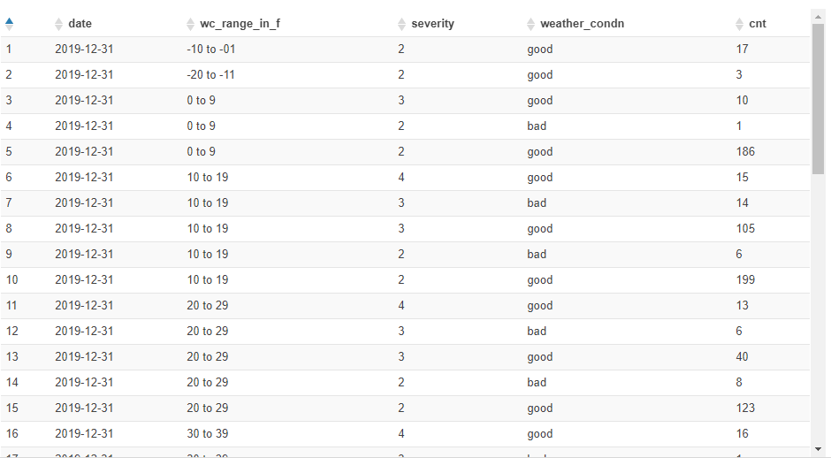

**humidity**

select distinct date, hum_range_in_f, severity, weather_condn, count(*) over (partition by weather_condn, severity, hum_range_in_f) as cnt

from

(select date(start_time) as date,

case

when humidity between 0 and 9 then '0 to 9'

when humidity between 10 and 19 then '10 to 19'

when humidity between 20 and 29 then '20 to 29'

when humidity between 30 and 39 then '30 to 39'

when humidity between 40 and 49 then '40 to 49'

when humidity between 50 and 59 then '50 to 59'

when humidity between 60 and 69 then '60 to 69'

when humidity between 70 and 79 then '70 to 79'

when humidity between 80 and 89 then '80 to 89'

when humidity between 90 and 99 then '90 to 99'

when humidity between 100 and 109 then '100 to 109'

else 'humidity unknown'

end as hum_range_in_f,

case

when weather_condition = 'Clear' then 'good'

when weather_condition = 'Cloudy' then 'good'

when weather_condition = 'Cloudy / Windy' then 'good'

when weather_condition = 'Drizzle' then 'good'

when weather_condition = 'Drizzle / Windy' then 'good'

when weather_condition = 'Fair' then 'good'

when weather_condition = 'Fair / Windy' then 'good'

when weather_condition = 'Haze' then 'good'

when weather_condition = 'Light Blowing Snow' then 'good'

when weather_condition = 'Light Drizzle' then 'good'

when weather_condition = 'Light Drizzle / Windy' then 'good'

when weather_condition = 'Light Fog' then 'good'

when weather_condition = 'Light Freezing Drizzle' then 'good'

when weather_condition = 'Light Freezing Fog' then 'good'

when weather_condition = 'Light Freezing Rain' then 'good'

when weather_condition = 'Light Freezing Rain / Windy' then 'good'

when weather_condition = 'Light Hail' then 'good'

when weather_condition = 'Light Haze' then 'good'

when weather_condition = 'Light Ice Pellets' then 'good'

when weather_condition = 'Light Rain' then 'good'

when weather_condition = 'Light Rain / Windy' then 'good'

when weather_condition = 'Light Rain Shower' then 'good'

when weather_condition = 'Light Rain Shower / Windy' then 'good'

when weather_condition = 'Light Rain Showers' then 'good'

when weather_condition = 'Light Sleet' then 'good'

when weather_condition = 'Light Snow' then 'good'

when weather_condition = 'Light Snow and Sleet' then 'good'

when weather_condition = 'Light Snow Grains' then 'good'

when weather_condition = 'Light Snow Shower' then 'good'

when weather_condition = 'Light Snow Showers' then 'good'

when weather_condition = 'Light Thunderstorms and Rain' then 'good'

when weather_condition = 'Light Thunderstorms and Snow' then 'good'

when weather_condition = 'Mist' then 'good'

when weather_condition = 'Mostly Cloudy' then 'good'

when weather_condition = 'Mostly Cloudy / Windy' then 'good'

when weather_condition = 'N/A Precipitation' then 'good'

when weather_condition = 'Overcast' then 'good'

when weather_condition = 'Partial Fog' then 'good'

when weather_condition = 'Partial Fog / Windy' then 'good'

when weather_condition = 'Partly Cloudy' then 'good'

when weather_condition = 'Partly Cloudy / Windy' then 'good'

when weather_condition = 'Patches of Fog' then 'good'

when weather_condition = 'Scattered Clouds' then 'good'

when weather_condition = 'Shallow Fog' then 'good'

when weather_condition = 'Showers in the Vicinity' then 'good'

when weather_condition = 'Small Hail' then 'good'

when weather_condition = 'Thunder in the Vicinity' then 'good'

else 'bad'

end as weather_condn, severity

from us_accident_v3

where year(start_time) = 2019 and month(start_time) = 12 and day(start_time) = 31

order by month(start_time), date(start_time))

order by hum_range_in_f, severity desc, weather_condn, cnt desc;

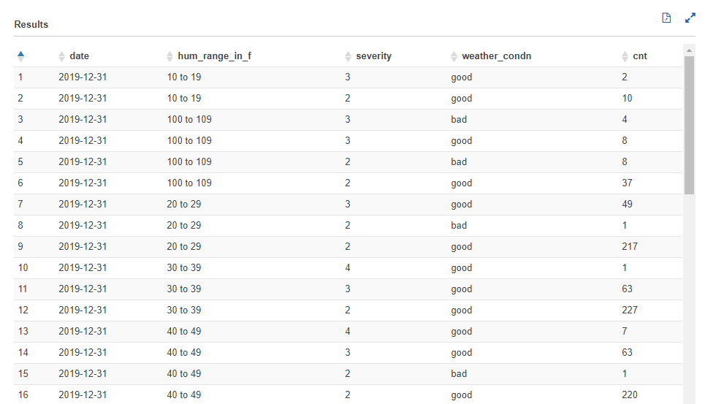

**pressure**

select distinct date, press_range_in_f, severity, weather_condn, count(*) over (partition by weather_condn, severity, press_range_in_f) as cnt

from

(select date(start_time) as date,

case

when pressure between 0 and 9 then '0 to 9'

when pressure between 10 and 19 then '10 to 19'

when pressure between 20 and 29 then '20 to 29'

when pressure between 30 and 39 then '30 to 39'

else 'pressure unknown'

end as press_range_in_f,

case

when weather_condition = 'Clear' then 'good'

when weather_condition = 'Cloudy' then 'good'

when weather_condition = 'Cloudy / Windy' then 'good'

when weather_condition = 'Drizzle' then 'good'

when weather_condition = 'Drizzle / Windy' then 'good'

when weather_condition = 'Fair' then 'good'

when weather_condition = 'Fair / Windy' then 'good'

when weather_condition = 'Haze' then 'good'

when weather_condition = 'Light Blowing Snow' then 'good'

when weather_condition = 'Light Drizzle' then 'good'

when weather_condition = 'Light Drizzle / Windy' then 'good'

when weather_condition = 'Light Fog' then 'good'

when weather_condition = 'Light Freezing Drizzle' then 'good'

when weather_condition = 'Light Freezing Fog' then 'good'

when weather_condition = 'Light Freezing Rain' then 'good'

when weather_condition = 'Light Freezing Rain / Windy' then 'good'

when weather_condition = 'Light Hail' then 'good'

when weather_condition = 'Light Haze' then 'good'

when weather_condition = 'Light Ice Pellets' then 'good'

when weather_condition = 'Light Rain' then 'good'

when weather_condition = 'Light Rain / Windy' then 'good'

when weather_condition = 'Light Rain Shower' then 'good'

when weather_condition = 'Light Rain Shower / Windy' then 'good'

when weather_condition = 'Light Rain Showers' then 'good'

when weather_condition = 'Light Sleet' then 'good'

when weather_condition = 'Light Snow' then 'good'

when weather_condition = 'Light Snow and Sleet' then 'good'

when weather_condition = 'Light Snow Grains' then 'good'

when weather_condition = 'Light Snow Shower' then 'good'

when weather_condition = 'Light Snow Showers' then 'good'

when weather_condition = 'Light Thunderstorms and Rain' then 'good'

when weather_condition = 'Light Thunderstorms and Snow' then 'good'

when weather_condition = 'Mist' then 'good'

when weather_condition = 'Mostly Cloudy' then 'good'

when weather_condition = 'Mostly Cloudy / Windy' then 'good'

when weather_condition = 'N/A Precipitation' then 'good'

when weather_condition = 'Overcast' then 'good'

when weather_condition = 'Partial Fog' then 'good'

when weather_condition = 'Partial Fog / Windy' then 'good'

when weather_condition = 'Partly Cloudy' then 'good'

when weather_condition = 'Partly Cloudy / Windy' then 'good'

when weather_condition = 'Patches of Fog' then 'good'

when weather_condition = 'Scattered Clouds' then 'good'

when weather_condition = 'Shallow Fog' then 'good'

when weather_condition = 'Showers in the Vicinity' then 'good'

when weather_condition = 'Small Hail' then 'good'

when weather_condition = 'Thunder in the Vicinity' then 'good'

else 'bad'

end as weather_condn, severity

from us_accident_v3

where year(start_time) = 2019 and month(start_time) = 12 and day(start_time) = 31

order by month(start_time), date(start_time))

order by press_range_in_f, severity desc, weather_condn, cnt desc;

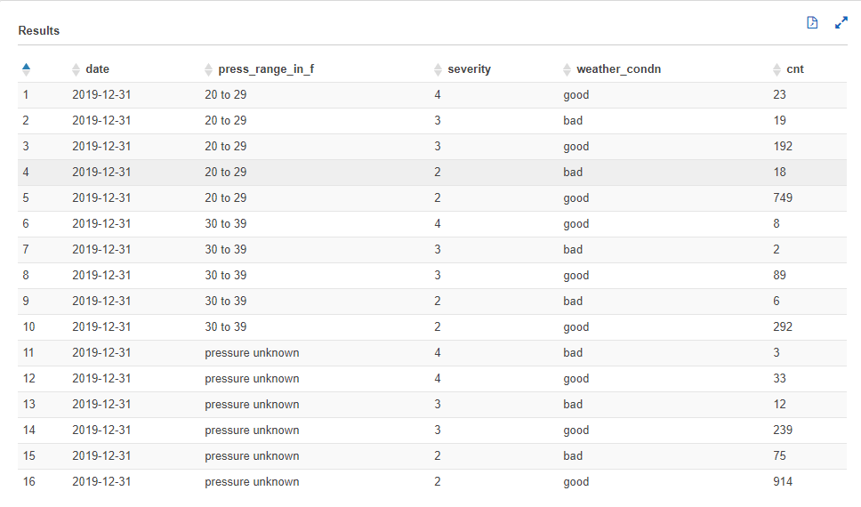

**visibility**

**wind-speed**

**precipitation**

**Bump**

**Crossing**

**Give_Way**

**Junction**

**No_Exit**

**Railway**

**Roundabout**

**Station**

**Stop**

**Traffic_Calming**

**Traffic_Signal**

**Turning_Loop**

## Query 6

SELECT count(id) AS NumAcc,

severity,

extract(week

FROM start_time) AS week

FROM timezone_table us_accident_v3

WHERE (extract(year

FROM start_time) > 2015

AND extract(month

FROM start_time)>1)

OR (extract(year

FROM start_time) > 2016)

GROUP BY severity, extract(week

FROM start_time);

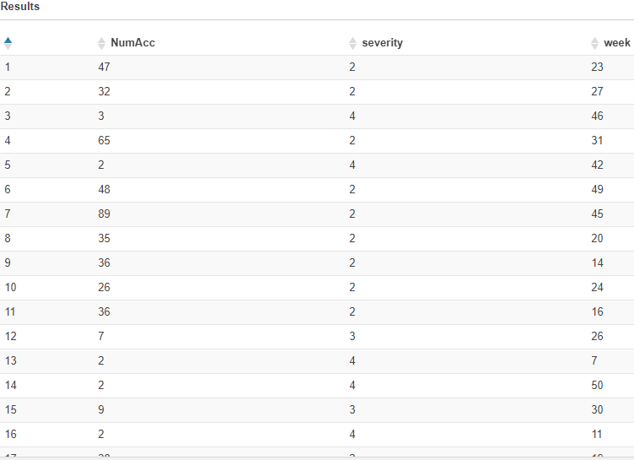

## Query 7

SELECT severity,

avg(distance) AS AvgDis,

stddev(distance) AS StdDevDis,

max(distance) AS MaxDis

FROM us_accident_v3

GROUP BY severity

ORDER BY severity

## Query 10

## with cte1 AS

## (SELECT b.slno,

## b.pattrn,

## cardinality(regexp_extract_all(lower(a.n_description),

## lower(b.pattrn))) count

## FROM base_corpus3 a

## CROSS JOIN concept7 b

## ORDER BY slno)

## SELECT DISTINCT slno as Serial_No,

## pattrn as Pattern,

## sum(count)

## OVER (partition by pattrn) AS Frequency

## FROM cte1

## ORDER BY slno;

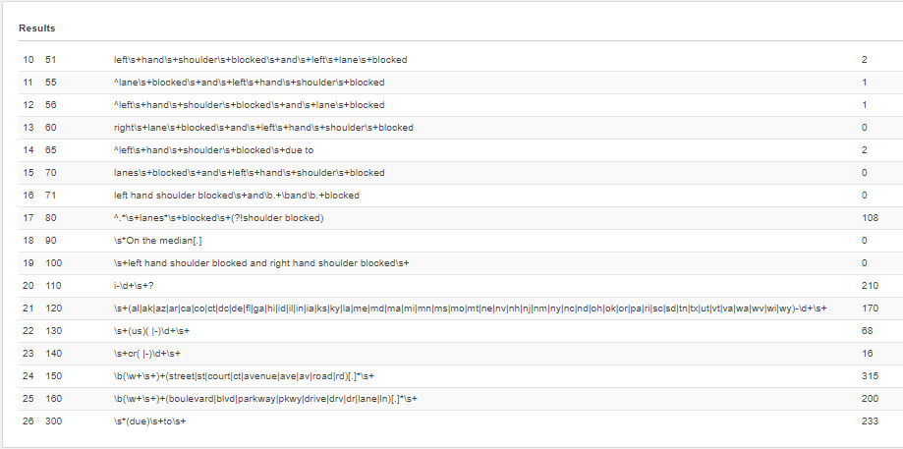

## Query 12

with q_12_int AS

(SELECT DISTINCT state,

zipcode,

date(start_time) AS date_,

sum(precipitation)

OVER (partition by date(start_time), zipcode, state) AS total

FROM us_accident_v3

WHERE (upper(weather_condition) LIKE upper('%rain%')

OR upper(weather_condition) LIKE upper('%cloudy%')

OR upper(weather_condition) LIKE upper('%overcast%'))

AND precipitation > 0

ORDER BY state, zipcode, date_, total desc)

SELECT DISTINCT state,

date_,

avg(total)

OVER (partition by date_, state) AS avg_

FROM q_12_int

ORDER BY state, date_, avg_ desc;

## Query 13

SELECT DISTINCT state,

date(start_time) AS date_,

precipitation,

count(*)

OVER (partition by precipitation, date(start_time), state) AS count

FROM us_accident_v3

WHERE precipitation IS NOT NULL

